Project Title
Project Documentation

1.Introduction
- Project title : Health AI
- Team member : Oviya Priya. S
- Team member : Lavanya .P
- Team member : Jeeva.J
- Team member : kalai Selvi .R

2.project overview
- Purpose :
HealthAI is designed to assist patients, doctors, and healthcare providers by offering AI-powered support for diagnosis, medical record management, and personalized health recommendations. The system leverages AI and data analytics to improve treatment efficiency, provide preventive healthcare tips, and simplify medical decision-making. Ultimately, it bridges healthcare technology and patient engagement for better well-being.
- Features :
  - Conversational Interface
    - Key Point: Natural language interaction
    - Functionality: Patients can ask health-related questions and receive AI-generated responses in plain language
  - Symptom Checker
    - Key Point: Early diagnosis support
    - Functionality: Suggests possible conditions based on symptoms entered by the user
  - Medical Record Management
  - Key Point: Organized patient data
  - Functionality: Stores, retrieves, and summarizes patient health records
- Prescription Reminder
  - Key Point: Patient support
  - Functionality: Alerts patients to take medicines on time
- Health Tips Generator
  - Key Point: Preventive care
  - Functionality: Provides daily personalized tips to improve lifestyle and well-being
- Doctor–Patient Interaction
  - Key Point: Virtual consultation
  - Functionality: Enables patients to share symptoms, documents, and get feedback from doctors
- Anomaly Detection
  - Key Point: Alert system
  - Functionality: Identifies abnormal health patterns like unusual heart rate or blood sugar levels
- Multimodal Input Support
  - Key Point: Flexible data handling
  - Functionality: Accepts text, PDFs, or images (like prescriptions, lab reports) for analysis
- User-Friendly Dashboard
  - Key Point: Accessible interface
  - Functionality: Provides an intuitive UI for patients, doctors, and healthcare staff

3. Architecture
- Frontend (Streamlit) :Web-based interface for patients and doctors, including dashboards, chat, health tips, and medical records viewer
- Backend (FastAPI) :REST framework powering APIs for chat, health record management, anomaly detection, and reminders
- LLM Integration (IBM Watsonx Granite) : Provides health-related summaries, recommendations, and patient-doctor communication support
- Database (MongoDB / SQL) : Stores patient details, health records, prescriptions, and reminders
- ML Modules (Scikit-learn / TensorFlow) : o Symptom checker using classification models o Anomaly detection in patient data
o Health forecasting (e.g., sugar levels, BMI trends)

4. Setup Instructions
- Prerequisites :
  - Python 3.9 or later o pip and virtual environment tools o API keys for Watsonx / cloud integrations o Database setup (MongoDB or SQL)
- Installation Process :
  - Clone the repository
  - Install dependencies from requirements.txt o Configure .env file with credentials o Run backend server using FastAPI o Launch frontend via Streamlit
  - Upload patient data and interact with modules

5. Folder Structure
• app/ – Backend logic with routers and services
• app/api/ – APIs (chat, health records, reminders, anomaly detection)
• ui/ – Streamlit pages and dashboards
• health_dashboard.py – Launches main Streamlit dashboard
• symptom_checker.py – Suggests possible conditions
• record_manager.py – Stores and summarizes patient data
• anomaly_detector.py – Detects unusual health values
• reminder_service.py – Manages prescription reminders
• report_generator.py – Generates health summary reports

6. Running the Application
- Start FastAPI backend server
- Run Streamlit dashboard
- Navigate through sidebar to access modules
- Upload health data or reports
- Chat with AI assistant or view forecasts and reminders
- Download reports or share with doctors

7. API Documentation
POST /chat/ask – AI health query responses
POST /upload-record – Upload patient health record GET /search-records – Retrieve patient history
GET /get-health-tips – Provides daily health tips
POST /set-reminder – Create prescription or appointment reminders
Documented with Swagger UI for testing

. 8. Authentication
- Current version: Open environment (demo)
- Secure deployment options:
o Token-based authentication (JWT, API keys) o Role-based access (doctor, patient, admin) o Encrypted storage for sensitive data o Planned session & history tracking

9. User Interface
The interface is a clean, user-friendly health platform designed for accessibility and ease of use across all age groups. Key features include:
- Sidebar Navigation
A left-hand sidebar with simple input fields (name, age, gender, medical history, symptoms) for quick patient data entry.
- Patient Dashboard with Health KPIs
Displays a card-style summary of key health indicators (conditions, recommendations, therapy plans) with a clear typography hierarchy.
- Tabbed Layout
Tabs at the top or side for switching between:
o Chat / AI Consultation (for interactive health advice) o Health Tips (personalized lifestyle recommendations) o Records (medical history, prescriptions, reports)
- Smart Notifications
Reminder alerts for upcoming checkups, medications, or exercise sessions.
- Downloadable PDF Summaries
One-click option to export patient assessments or therapy plans into neatly formatted PDF files.
- Minimalist, Accessible Design o Large, high-contrast text for readability o Clear icons and spacing for easy navigation o Works seamlessly on desktop and mobile o Inclusive for both tech-savvy and non-technical users

10. Testing
Testing was done in multiple phases:
- Unit Testing: Symptom checker, anomaly detection, reminders
- API Testing: Swagger UI and Postman
- Manual Testing: Chat assistant, file uploads, record summaries
- Edge Cases: Malformed data, missing health records, invalid inputs
11.screen shots
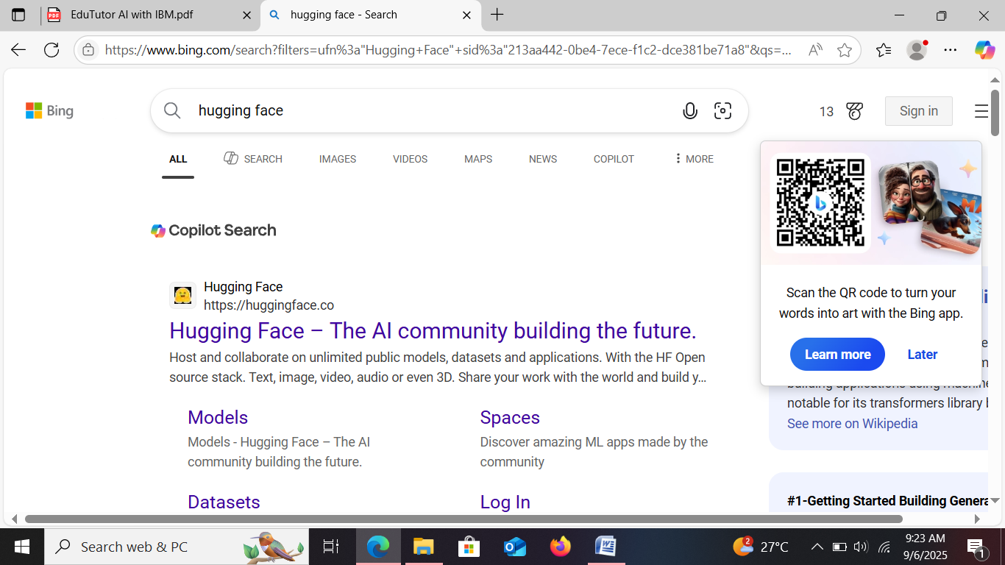

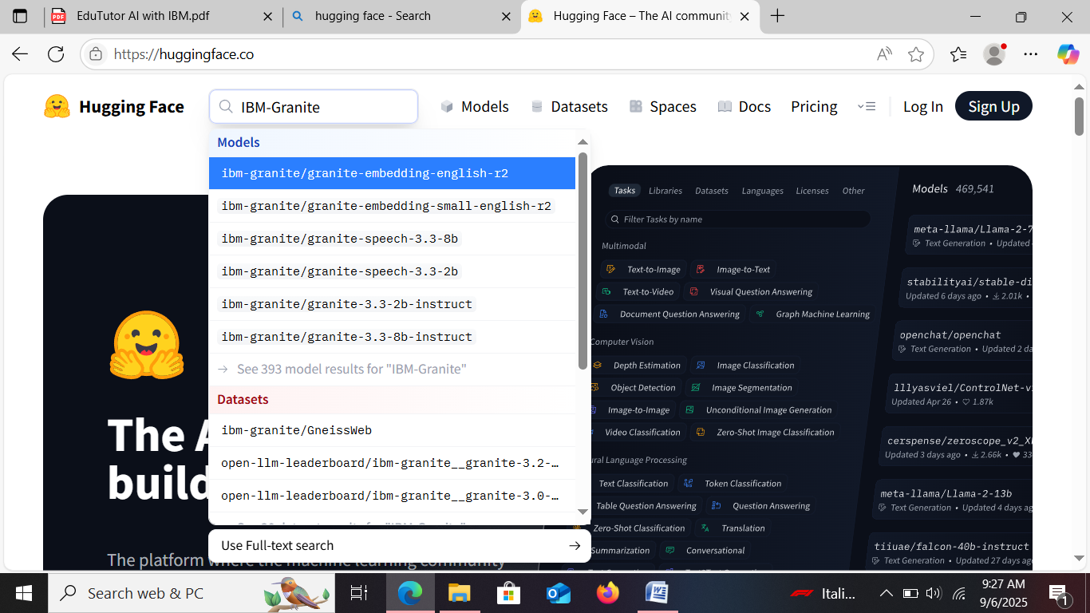

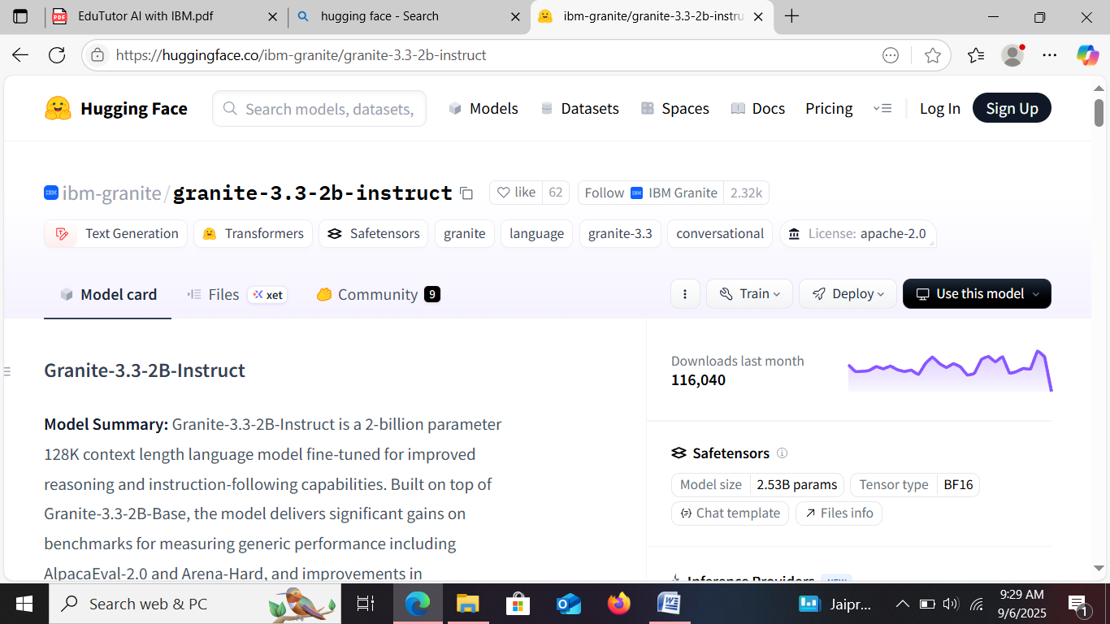

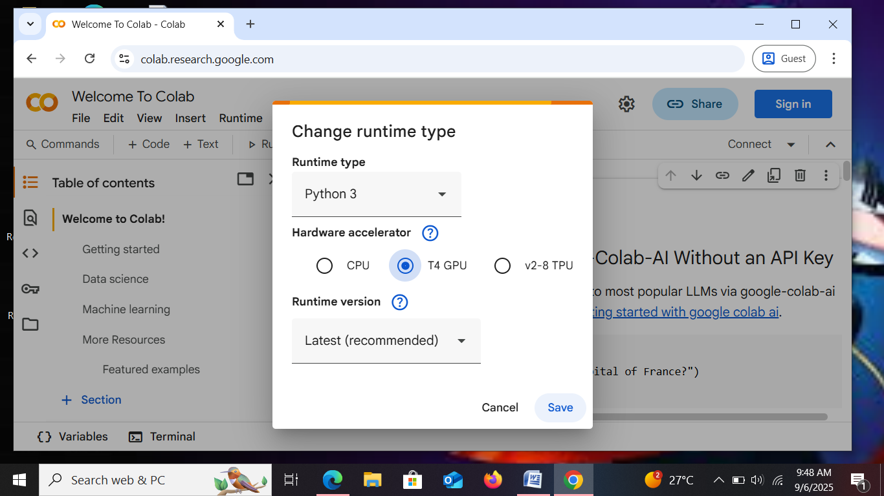
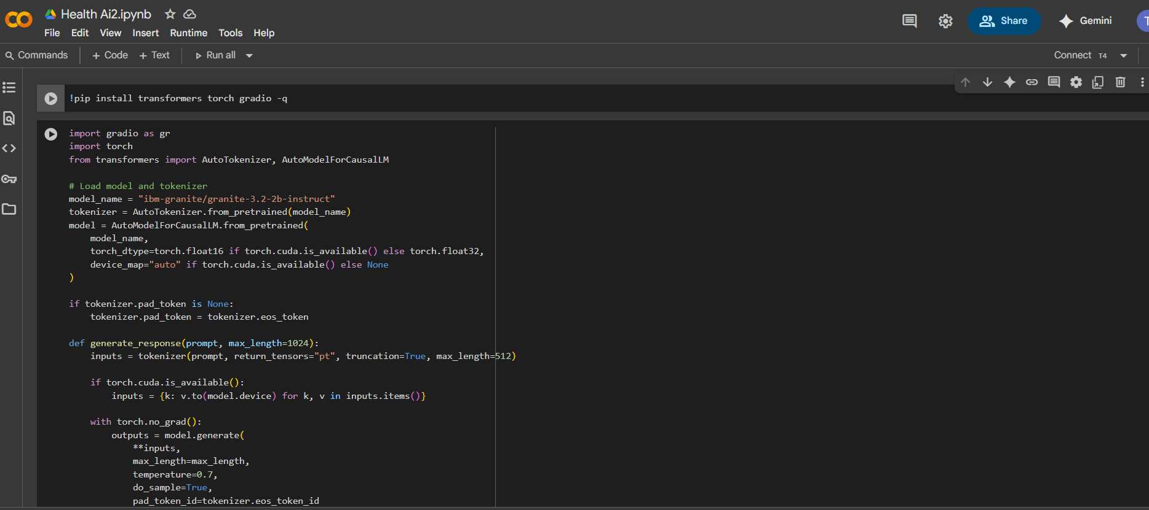
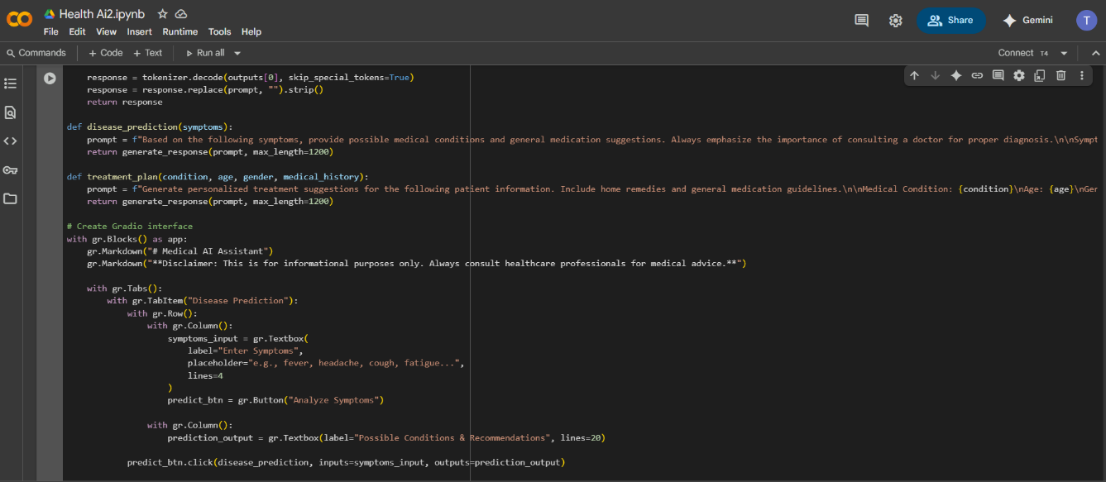
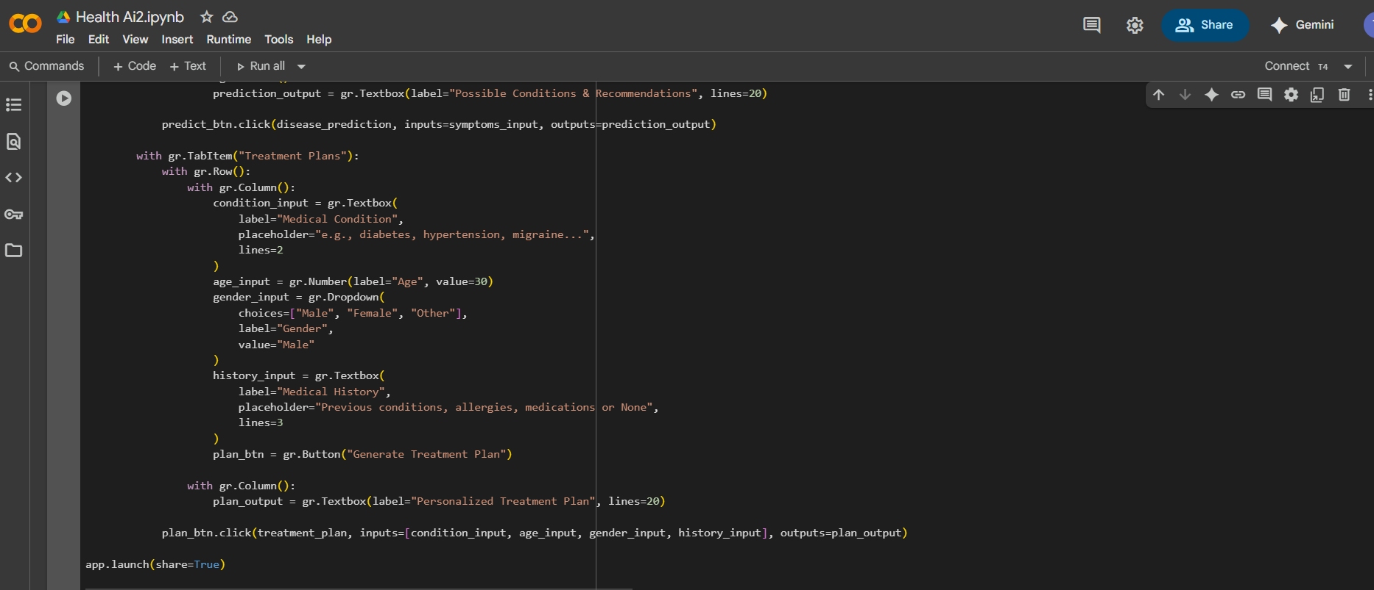
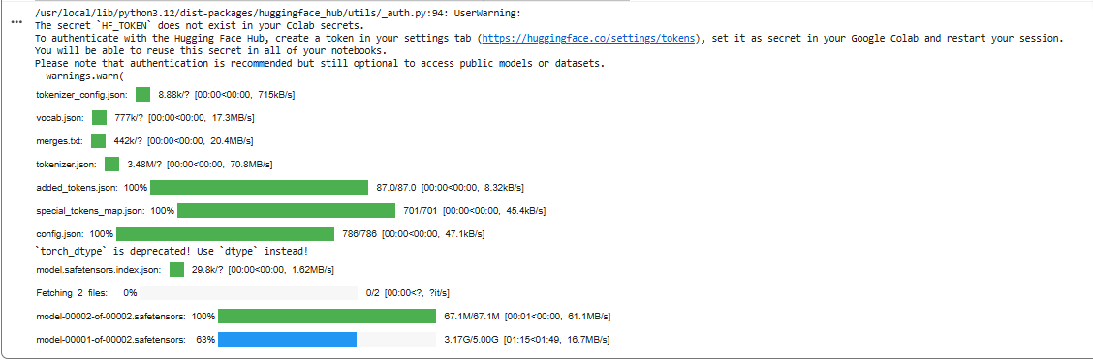
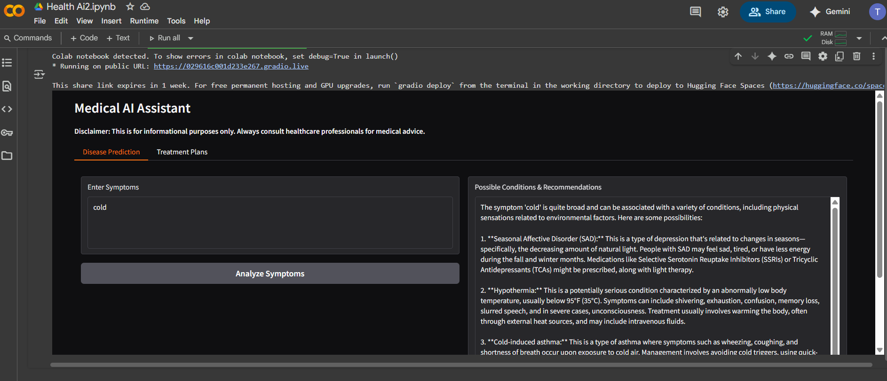
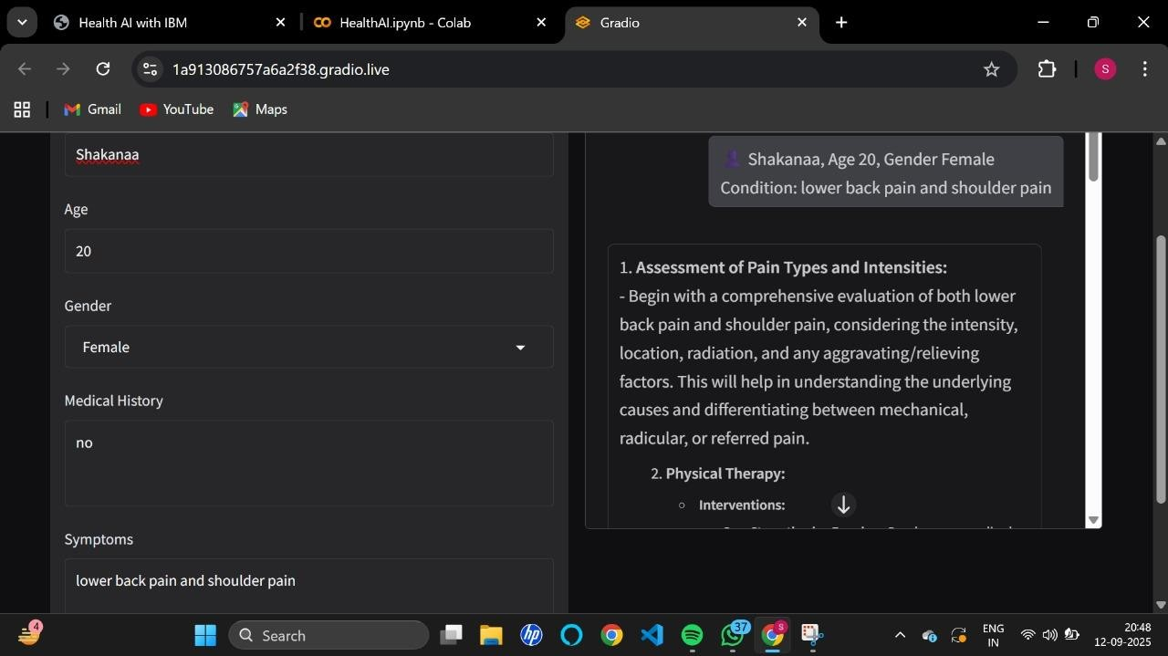

12. Known Issues
- Requires reliable internet for AI queries
- Limited offline functionality
- High dependency on cloud APIs

13. Future enhancement
- Mobile app version for patients
- Integration with IoT devices (smartwatches, glucose monitors)
- AI-powered disease prediction models
- Multi-language support for regional users
- Blockchain for secure medical record storage

